SBA 9

1. Start Eclipse and navigate to your workspace.
2. In Package Explorer, left-click on the project you want to export.
3. Right-click on the same project and select Export
4. When the Export dialog box pops up, expand Java and click on JAR file. ...
5. The JAR Export dialog will pop up. ...
6. Click Finish.

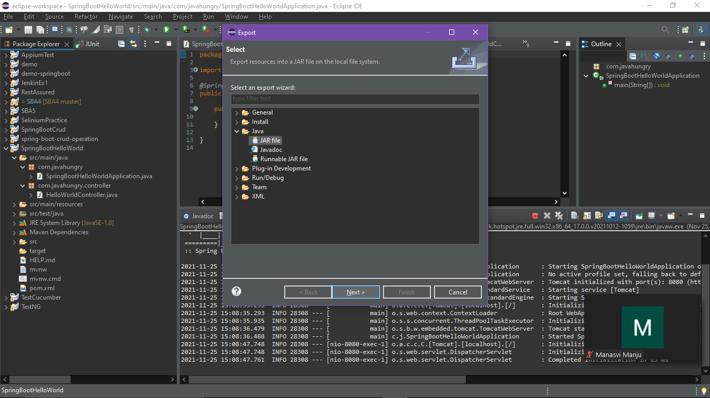

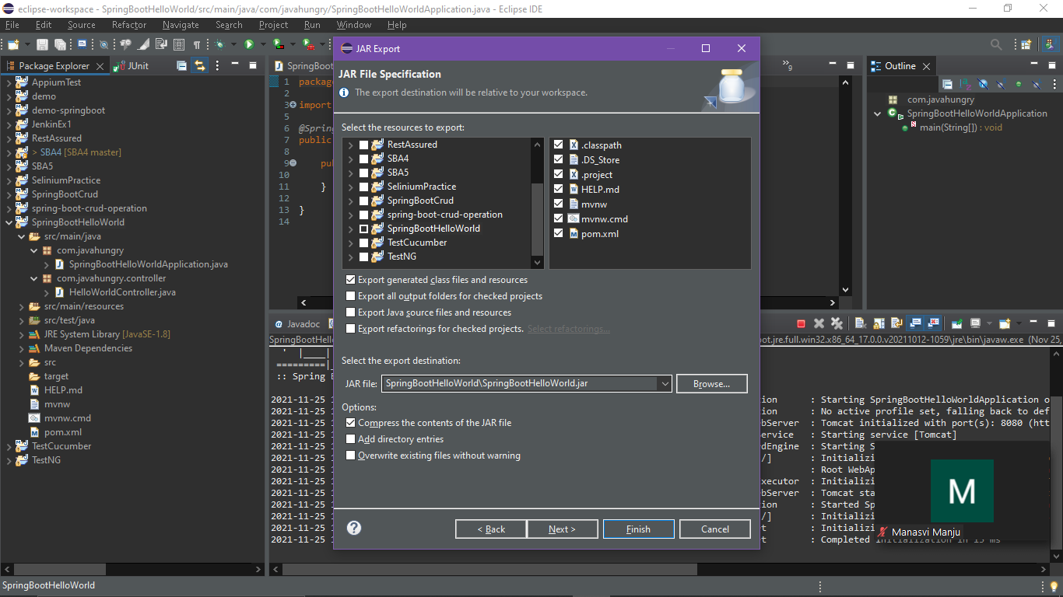

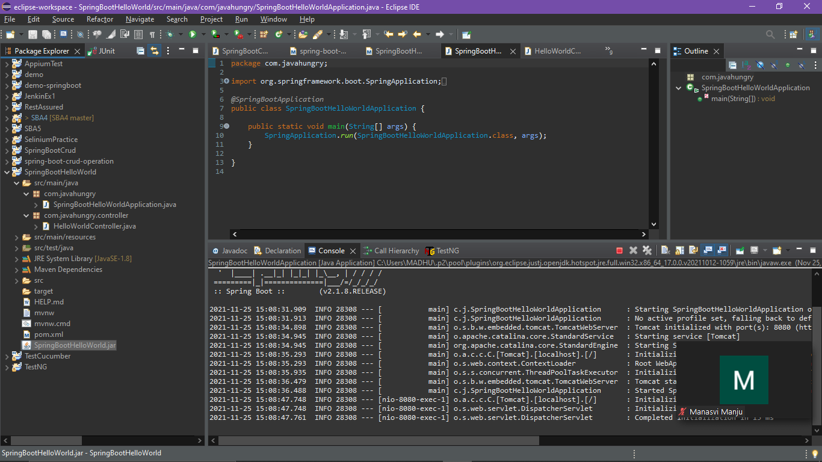

Step 2:

Create a bucket in aws console and save jar file inside that bucket

1. Go to sevices in the top and select S3.
2. Create a bucket inside that.
3. Upload your jar file into the bucket.

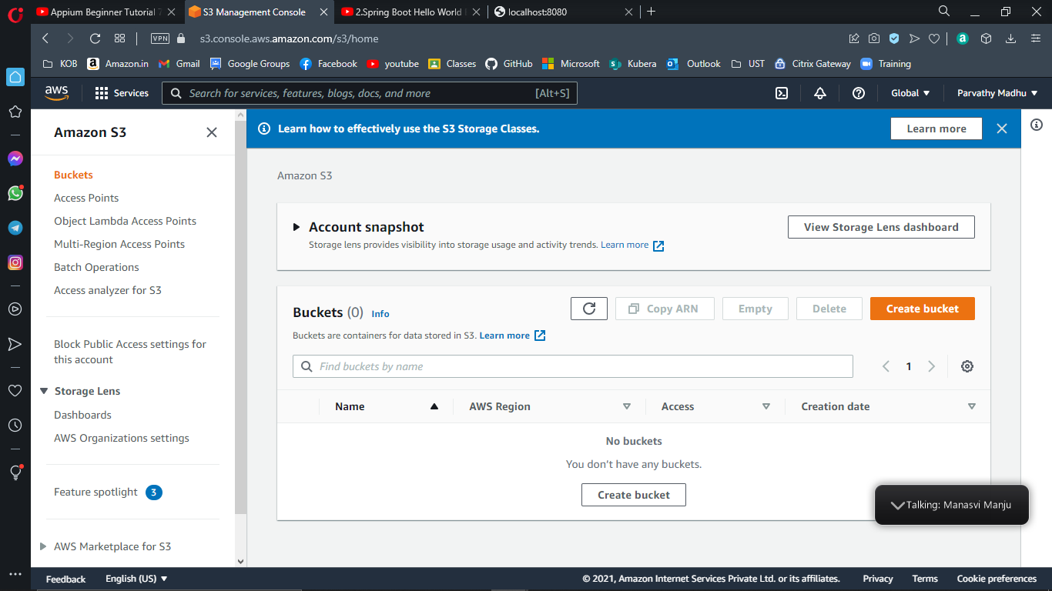

Create bucket

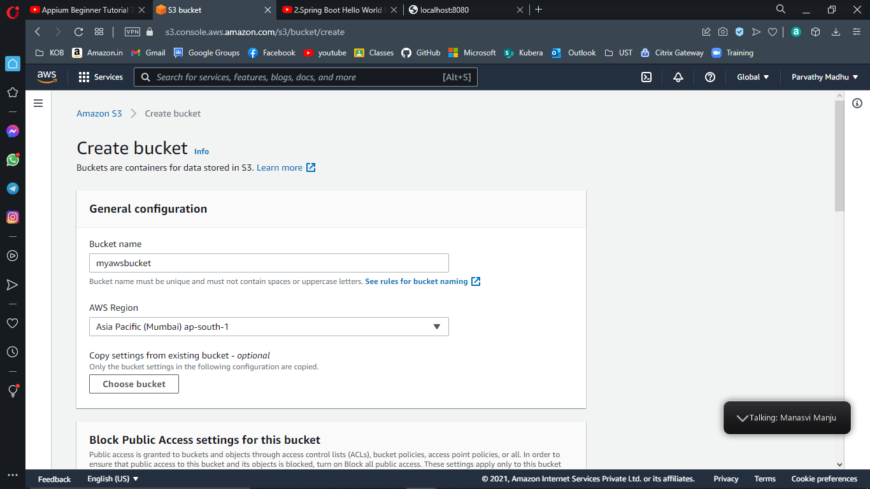

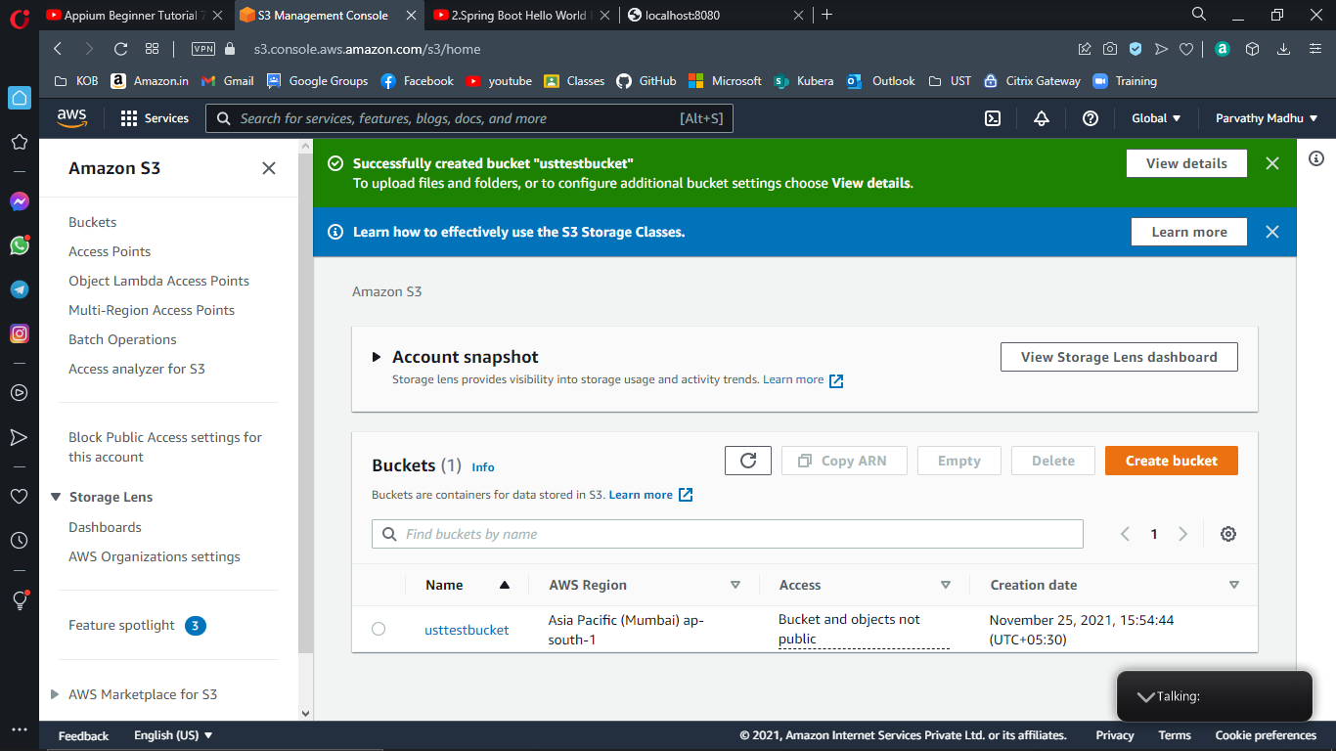

Step 3 : launching instance

1. Go to services 🡪 click on EC2 🡪 launch instance

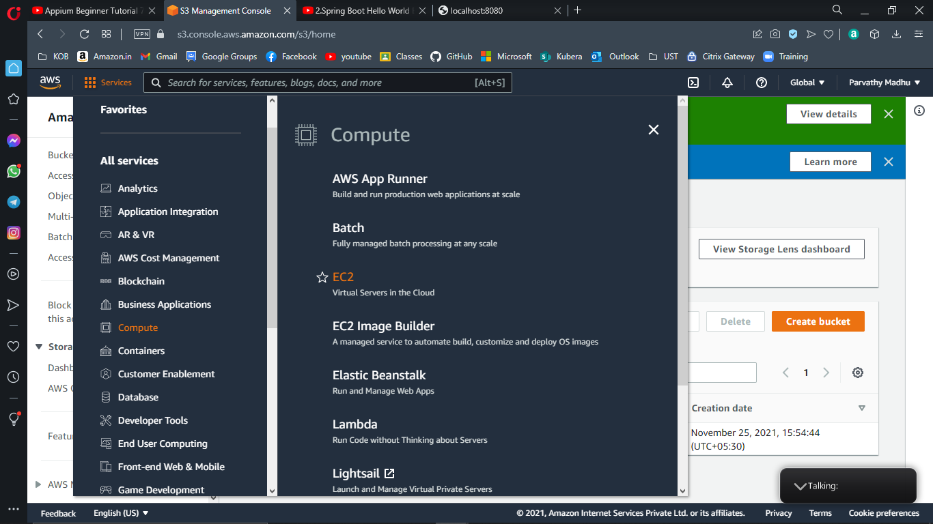

1. Choose AMI 🡪 Ubuntu

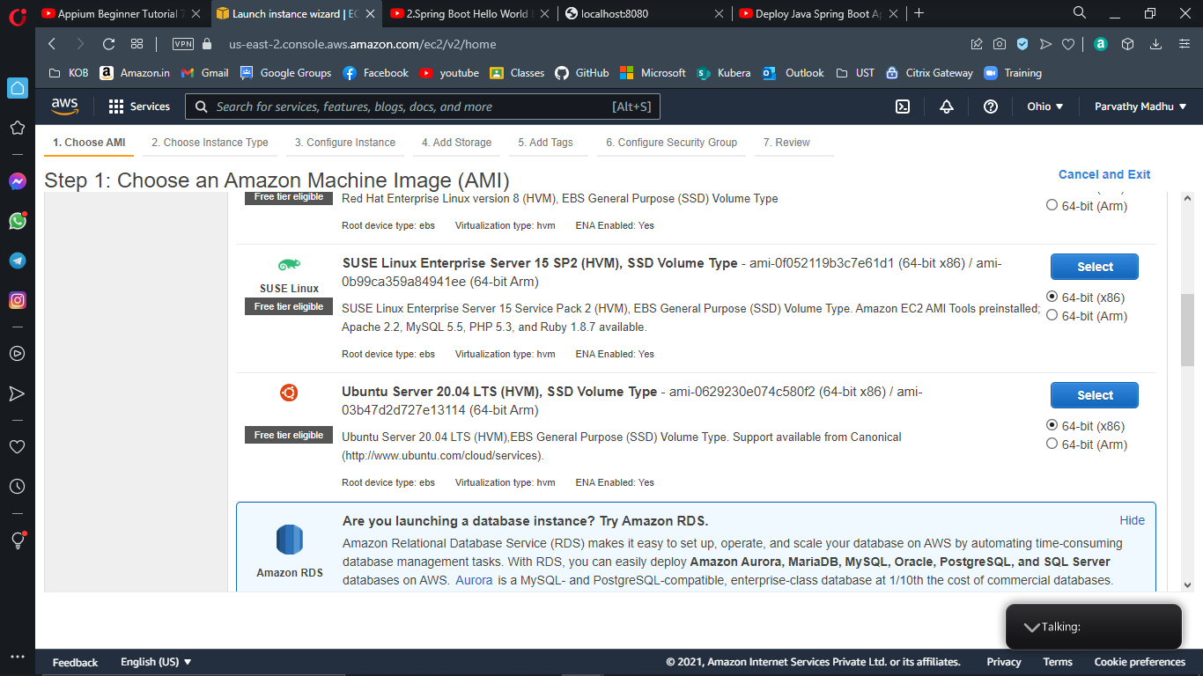

1. Click next configure instance details
2. Click next add storage
3. Click next add tags
4. Click next configure security groups
5. Add rule in the page 🡪 give port no as 8080 and source as anywhere

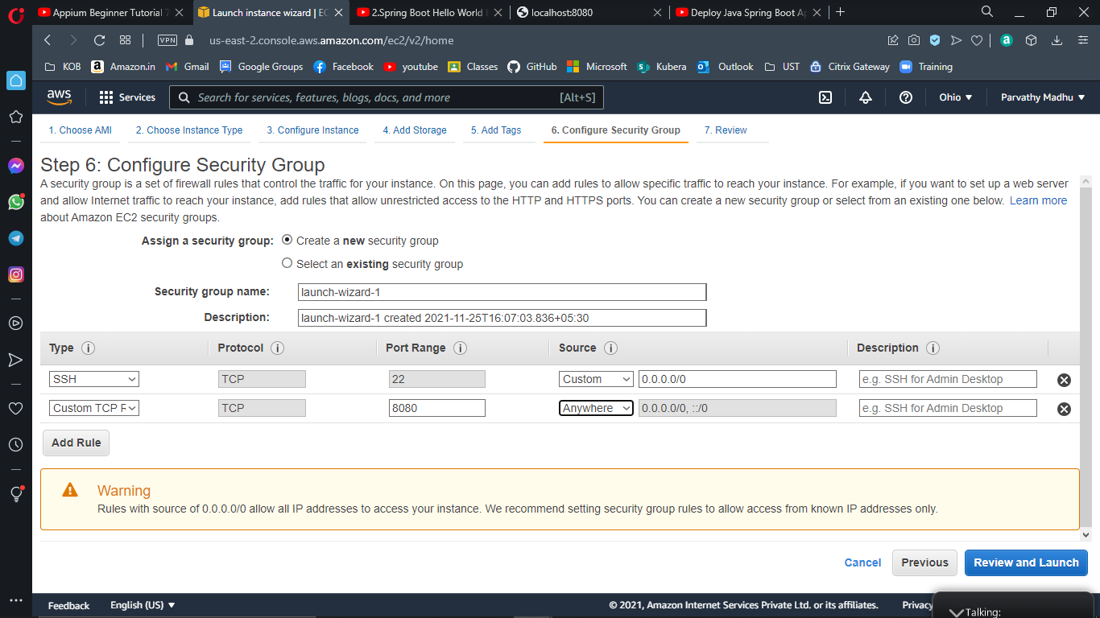

1. Click on review and launch🡪 click launch on next page
2. Select create a new key pair🡪choose key type as shown 🡪give a key name 🡪 download the key pair🡪 launch

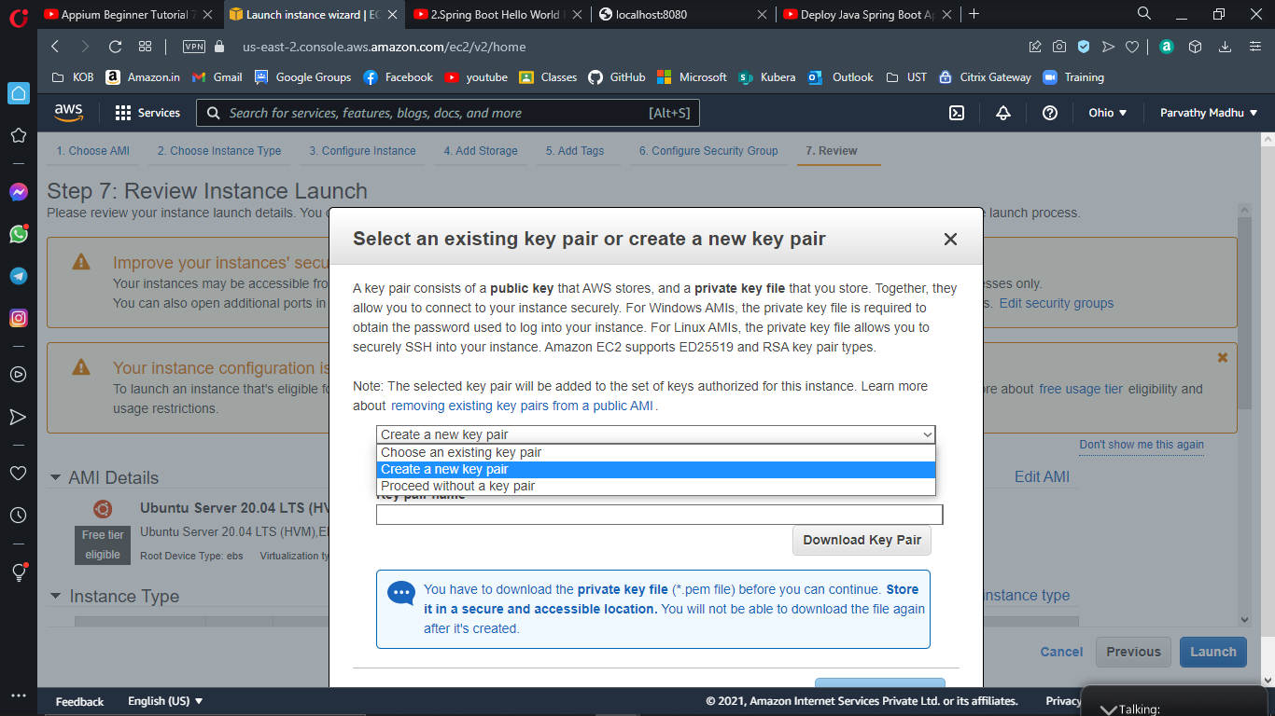

Downoad key pair

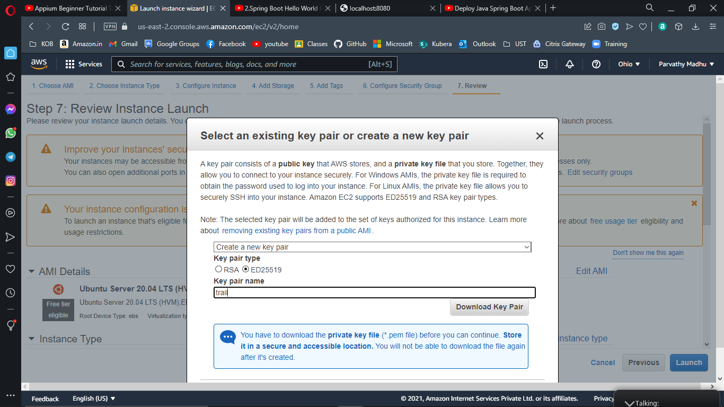

Edit name and save

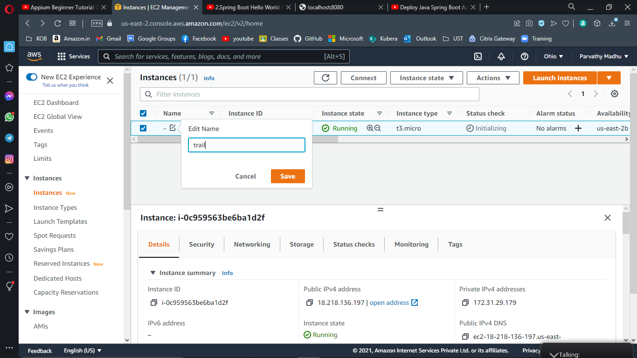

Connect instances

1. Click on the instance which you want to connect 🡪 click connect on the top

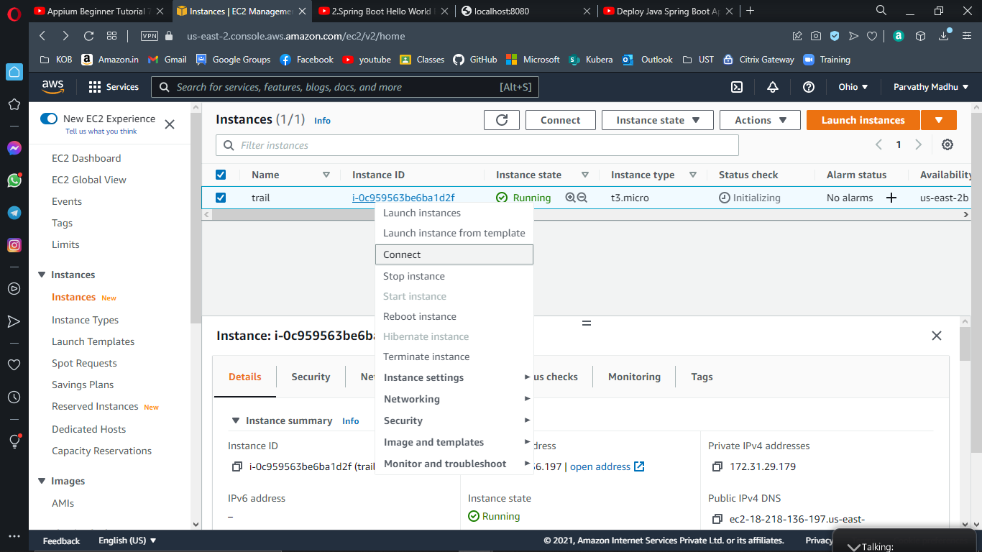

Copy the DNS

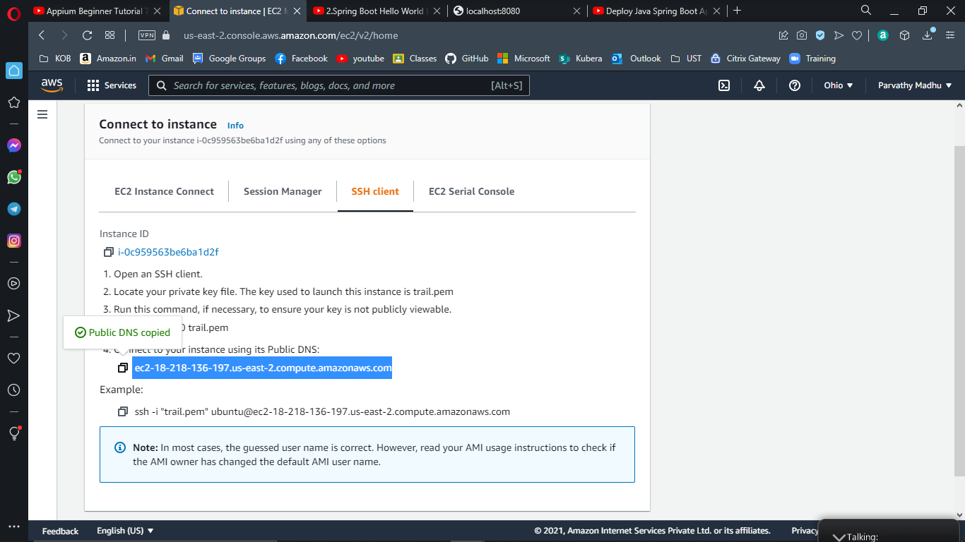

Step 5:

Download PuTTY from [www.putty.org](http://www.putty.org)

Open S3 Bucket

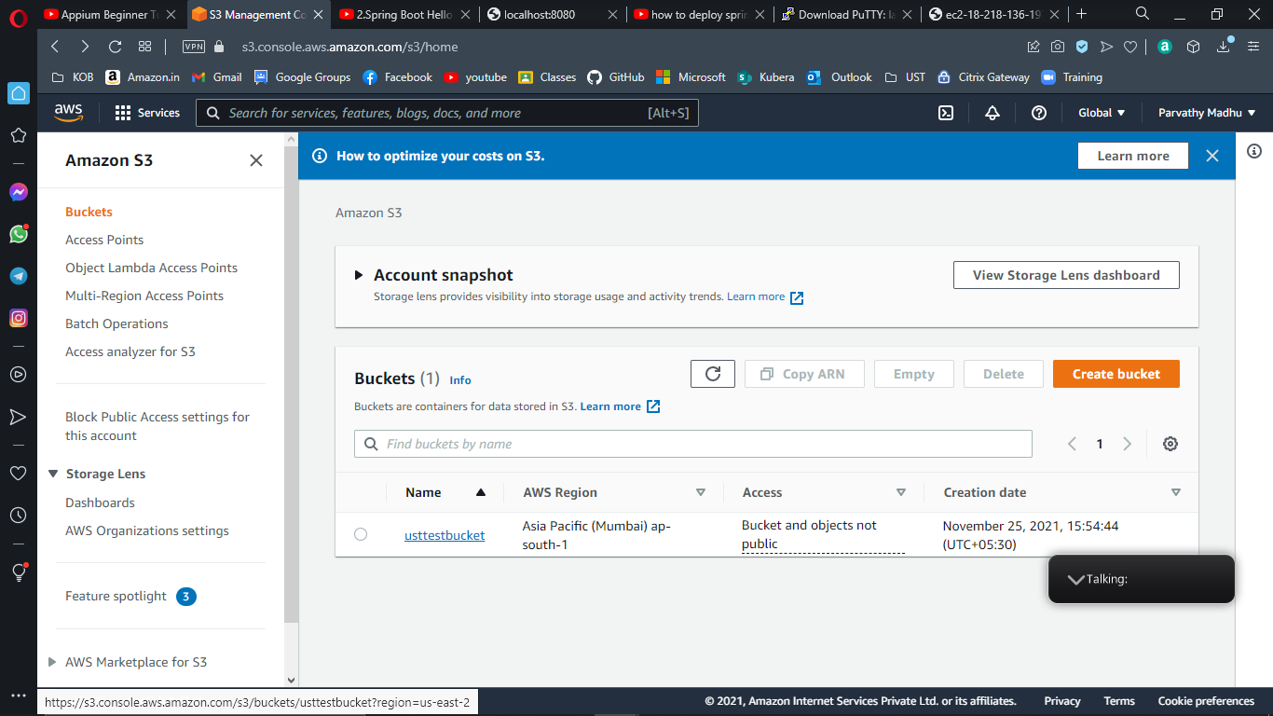

Upload

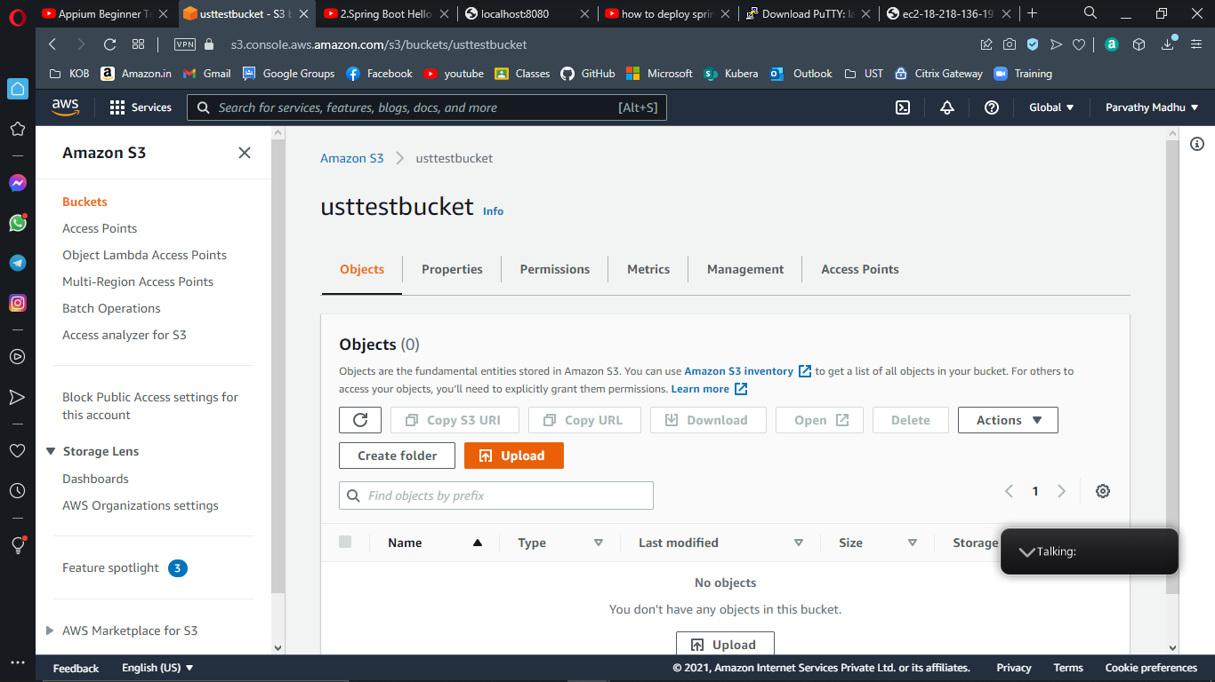

Add files or Add Folder

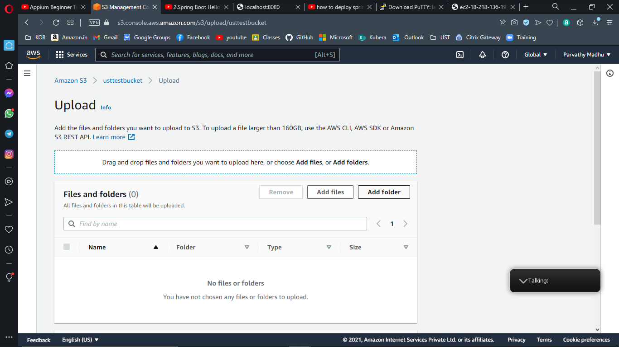

Choose or drag the files or folders, then click on **upload**

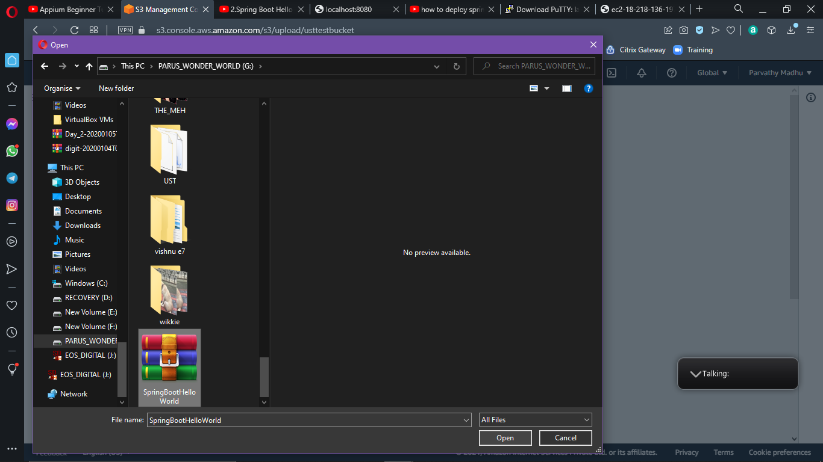

Click upload

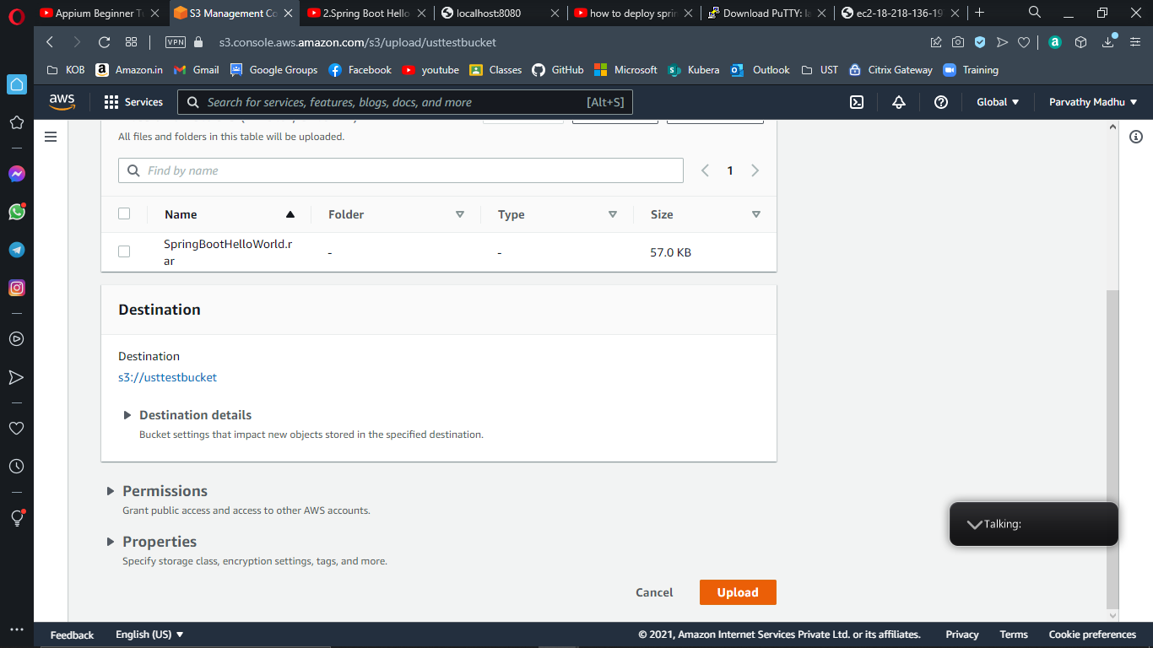

File uploaded successfully now we can see the file or folder in our bucket.

